Green is Ireland
Hi, my name is David Damjan Sremac. Until the age of 12, I have lived in Croatia and moved several times around the country, before we left Croatia to live in Ireland. We arrived in Dublin, the capital of Ireland, on the 16th July 2014.
Although we landed at the Dublin Shannon Airport, our destination was a smaller town that is located approximately 50 kilometres from Dublin and is called Drogheda. Our first Irish home was a Hostel, the “Spoon and Stars”. This is an amazing place to welcome people from all around the world, regardless of being tourists or a family like our which was searching for a new life.
Our new city, Drogheda, seemed to be quite a big city at that time, before we got to know it. We were walking a lot around and talking with many people, to learn as much as possible and as faster as possible about our new home town. My mum found a job at an Italian restaurant and although you maybe will not believe it, she would bring a pizza every night for free, what made our accommodation look like the home of the Ninja Turtles. We lived in the Hostel for about two months, before we rented our own home from a lovely Italian lady, the owner of the famous local fish & chips restaurant “Genoa”.
I started my 6th grade primary school in September 2014. In Ireland, most of the primary and secondary schools are divided into schools for boys and girls separately. You finish your primary school after 6th grade, start secondary education that lasts for 6 years and then you can go to college/university if you want to.
So, I spent only one year in primary school, before I started my secondary. We had to apply for my place in the new school a whole 1 year before my classes started, what was a really surprising system for us and although we were late with an application, I was the lucky one to get a place.
My secondary school is called Ballymakenny College, Educate Together (ET) and students are mixed on all possible ways – boys and girls, different races, different religious and non-religious backgrounds, different economical classes (although in Ireland many people are quite similar in wealth), etc. We do not have classic books, but IPADs, which we use to download e-books, study from there and of course, we use notebooks and pens/pencil to continue to express ourselves by writing. As my school and its program is very new, at the beginning we were using the top floor of a primary school also from the program Educate Together (this “Educate Together” name comes from the recognition of Irish people that is important to create society that will involve different people and give them space and chances). We moved to our own building in February 2014. When I stepped in our building for the first time, I was amazed how school is big and equipped with various classes, laboratories, gyms, cantina, offices, halls and other facilities. Although we still did not fill in all classes, we definitely filled in the gym, the great room with a lot of work-out equipment. And this is not only cool thing about the school! We also have seven science labs that we use to do all kinds of experiments almost every week.
We do not have many subjects and also not much homework after the school. However, we have very interesting classes with lot of discussions, presentations, experiments, group and individual projects. And yes, we had a chance to try different “choice” classes, before we choose our two favourite subjects. It helped me to find out how much I like technology and technology graphics. Ethics is also one of my favourite subjects, but is obligatory and we use this class to discuss our personal values and community issues and how we can help in our communities to resolve any problem and to be kind to each other.
I really like that all our teachers, principal and school staffs treat us with a respect, but also expect from us to respect them, each other and rules about the behaviour that we agreed. As I like to talk very much at school (and at home too!), I decided one day to NOT to talk at all, just to see the world from the listener’s perspective. My teachers and tutors allowed me this experiment, letting me to communicate with hands and nodding. Our school staffs have a lively and young spirit and all of them are very supportive and friendly to us. The best thing of all, we often have different community events, like carnivals, charity events, fundraising events, etc. and all our teachers participate with us. Sometimes they have the better masks and costumes then we!!!
And my new city, Drogheda! It is beautiful, full with medieval monuments, parks, museums, festivals and young musicians that sing in the centre of the city. The nature around Drogheda is beautiful, too, so we often visit farms, forests and little villages around with bikes. Of course, when is nice weather, as Irish climate is known as rainy and grey, especially over the winter. We are adjusting to this weather, because people are so nice and kind, so we do not care anymore about rainy days, as we just go to walk in our rainy coats. And have a lot of fun!
I am rushing now, to my friend’s birthday party, who is also bilingual so we like to talk on all possible languages that we now any word – Croatian, Serbian, English, Spanish, Irish, Thai – this is real fun!
Warm regards to everybody and as Irish people would say:
“Cead Mile Failte” – One hundred thousand welcomes
Puno pozdrava svima,
David Damjan Sremac
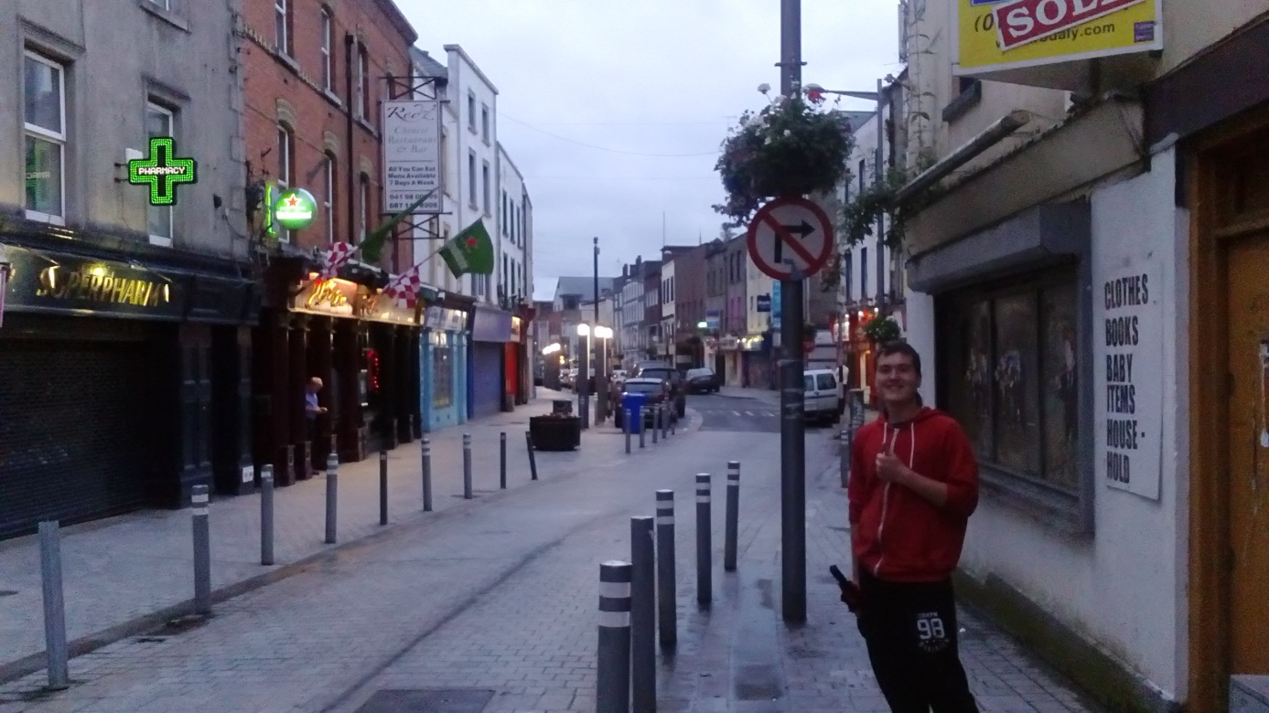

24th September, Drogheda, Ireland

